13.3 Rusting of metals
Name: ____________________ Class: ____________________ Due date: 5.22
1. The diagrams show two processes.
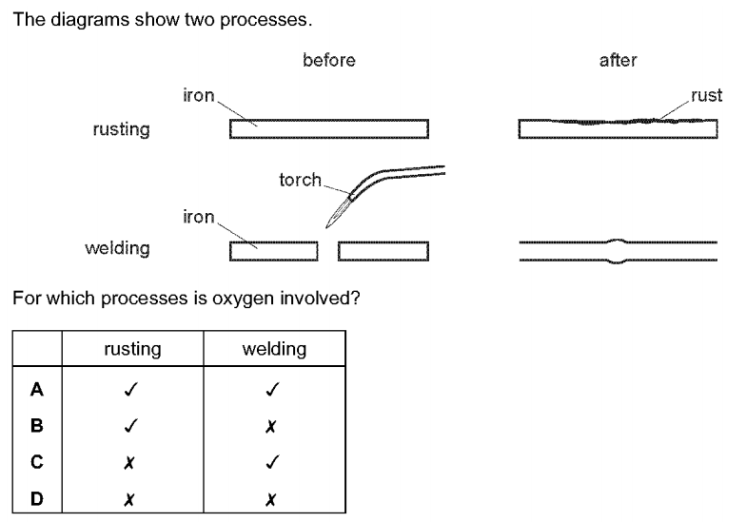
For which processes is oxygen involved （ ）

2. The diagrams show four uses of iron.
In which of these uses is the iron most likely to rust? （ ）
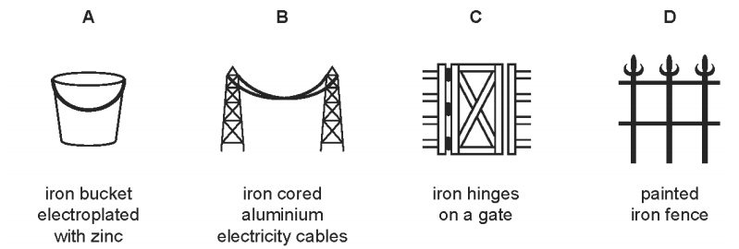
3. Iron rusts. This process involves the…..1…. of iron. Rusting can be prevented by covering the iron with grease or paint which stops…..2…. from reaching the surface of the iron.
Which words correctly complete gaps 1 and 2? （ ）
 | 1 | 2
A | oxidation | nitrogen
B | oxidation | oxygen
C | reduction | nitrogen
D | reduction | oxygen

4. Four steel paper clips are treated as described before being placed in a beaker of water.
Which paper clip rusts most quickly? （ ）
A coated with grease
B dipped in paint and allowed to dry
C electroplated with zinc
D washed with soap and rinsed

6. Which method is not used for rust prevention? （ ）
A coating working parts of industrial machinery with oil
B covering wire for gardening use with plastic
C immersing gardening tools in water for storage
D painting car bodies
5. A piece of uncoated iron and three pieces of iron with various coatings were left exposed to the air.
Which piece of iron would rust? （ ）
A the painted piece
B the tin-coated piece
C the uncoated piece
D the zinc-coated piece

7. A steel bicycle which had been left outdoors for several months was starting to rust.
What would not reduce the rate of corrosion? （ ）
A Remove the rust and paint the bicycle.
B Remove the rust and store the bicycle in a dry shed.
C Remove the rust and wipe the bicycle with a clean damp cloth.
D Remove the rust and wipe the bicycle with an oily cloth.

8. Underwater steel pipes can be protected from corrosion by attaching magnesium blocks to them.
Which equation represents the reaction that prevents corrosion? （ ）
A Fe → Fe²⁺ + 2e-
B Fe²⁺ → Fe³⁺+ e⁻
C $Mg →{Mg}^{2+}+2e^{−}$
D ${Mg}^{2+}+2e^{−}→Mg$

8. Boats made from steel can be protected from rusting by attaching blocks of a more reactive metal to the hull of the boat.
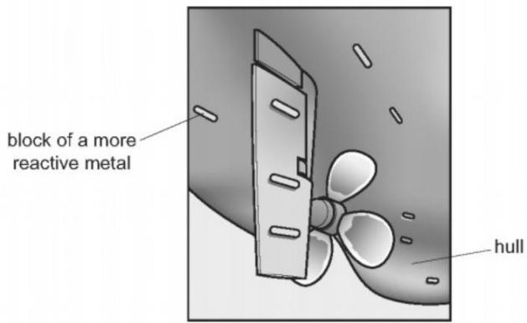
Which statement is correct? （ ）
A Copper is used for the blocks because it does not react with water.
B Magnesium is not used for the blocks because it reacts with steel.
C The metal used for the blocks loses electrons more easily than steel.
D This form of protection from rusting is called galvanising.

9. A metal, X, is used to make oil pipelines.
X corrodes in air and water.
X can be protected from corrosion by attaching blocks of element Y.
Which statement is correct? （ ）
A This process is known as galvanising.
B Y forms positive ions more readily than X.
C Y is an unreactive metal.
D Y is an unreactive non-metal.

10. The diagrams show experiments involving the rusting of iron.
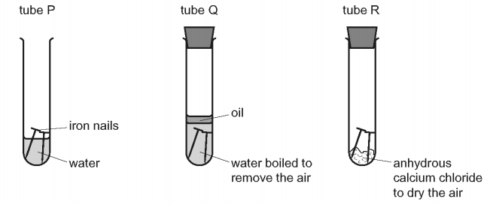
A student predicted the following results.
1 In tube P, the iron nails rust.
2 In tube Q, the iron nails do not rust.
3 In tube R, the iron nails do not rust.
Which predictions are correct?（ ）
A 1,2 and 3
B 1 and 2 only
C 1 and 3 only
D 2 and 3 only

11. The apparatus shown is set up and left for a week.

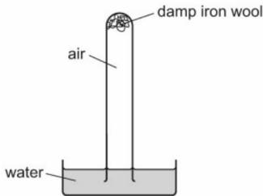
Which diagram shows the level of the water at the end of the week? （ ）
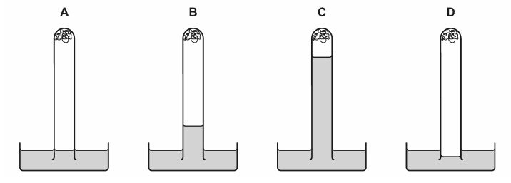
12. Rusting of steel can be prevented by coating the steel with a layer of zinc.
Explain, in terms of electron transfer, why steel does not rust even if the layer of zinc is scratched so that the steel is exposed to air and water.
Iron is a transition element.
Iron forms hydrated iron(III) oxide when it rusts.
Write a word equation to represent the formation of rust.
..............................................................................................................................[2]
When the transition element iron is added to water the iron rusts.
When an iron object is coated with a layer of zinc, rusting is prevented.
Name this process of coating iron objects with a layer of zinc.
...............................................................................................................................[1]
Explain how completely coating an iron object with a layer of zinc prevents rusting.
...............................................................................................................................[1]
Rusting of iron ships can be prevented by attaching zinc blocks to the hull of the ship. Explain how this prevents rusting.
...............................................................................................................................
...............................................................................................................................[2]

14. Steel nails rust in the presence of air and water. Plan an investigation to:
show that coating steel nails with paint helps to protect the nails from rusting
show that coating steel nails with zinc helps to protect the nails from rusting
determine which coating is more effective at protecting steel nails from rusting.
You are provided with:
uncoated steel nails
steel nails coated with paint
steel nails coated with zinc
common laboratory apparatus.
The metal iron and the alloy steel are commonly used materials. A problem with them is that they rust.
(a)How does painting iron and steel prevent rusting?
............................................................................................................................... [1]
(b)Magnesium blocks can be attached to the bottom of steel boats.
Explain how the magnesium blocks prevent the whole of the bottom of the boat from rusting.
...............................................................................................................................
...............................................................................................................................[2]
(c)Replacing the magnesium blocks with copper blocks does not prevent rusting.
Explain why the copper blocks do not prevent rusting.
...................................................................................................................................
................................................................................................................[1]

